Name: Luis Ruiz

Date/Time: February 15, 2022  
  
Class: PSCS_2302  
  
Tool being validated: USBWriteBlock  
  
Machine used to validate: Windows 10 Virtual Machine   
   
USB Information: Model: PNY USB 2.0 Drive

Colour: Black

Data Storage: 4 GB

Steps 1.  
I inserted the USB into the machine and used selected the USB in the Virtual Machine Menu to ensure that it is being used in the VM. I also checked the file folder to see that the virtual machine was connected to the VM.

Step 2.   
I used FTK imager to calculate the hash value of the USB.

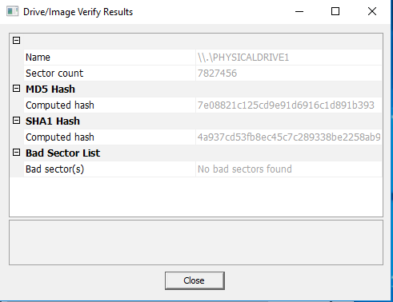

Steps 3.  
I opened the USBWriteBlock and changed the Write Block Status to enabled

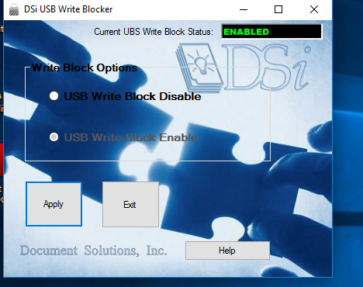

Steps 4.  
I searched the web for a picture of a pug and saved it. Then I tried to drag and drop the picture of the pug into the storage for the USB drive. The action should be interrupted if the USB is write-protected.

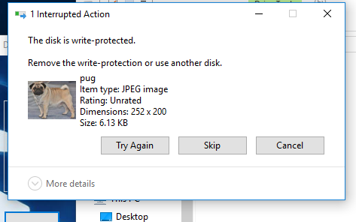

Steps 5.   
I ejected and removed the USB Drive and checked to make sure it was not available within the file folder.

Steps 6.  
I reinserted the USB Drive and checked the file folder to make sure there was nothing stored within it.

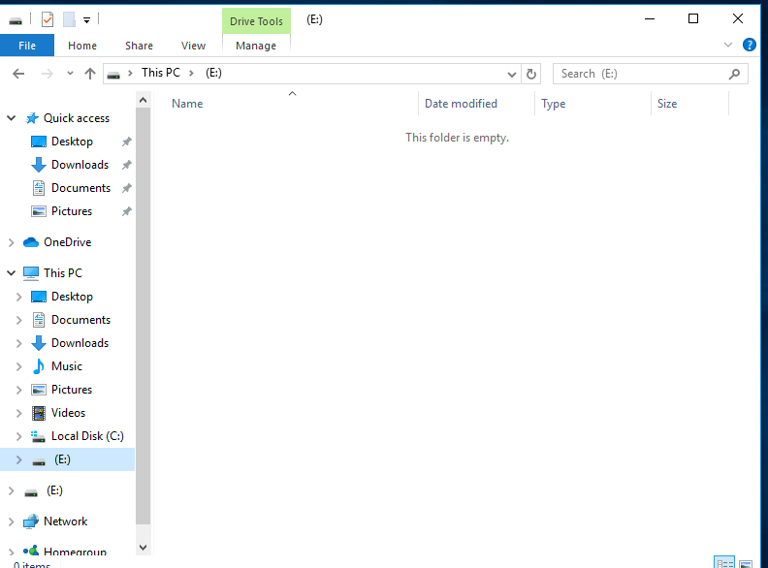

Steps 7.  
I opened FTK Imager and calculated the Hash to make sure it was the same as before we started.  
